

**iJOBS Workshop: Agile Project Management Tool**

**Thursday, October 14, 2021**

**6:00 PM**

**Jesse Fewell**

[https://www.linkedin.com/in/jessefewell/](https://nam02.safelinks.protection.outlook.com/?url=https%3A%2F%2Fwww.linkedin.com%2Fin%2Fjessefewell%2F&data=04%7C01%7Ccicoletm%40gsbs.rutgers.edu%7C9d039a44c62e4ed3e42808d98cbeb81a%7Cb92d2b234d35447093ff69aca6632ffe%7C1%7C0%7C637695573016656352%7CUnknown%7CTWFpbGZsb3d8eyJWIjoiMC4wLjAwMDAiLCJQIjoiV2luMzIiLCJBTiI6Ik1haWwiLCJXVCI6Mn0%3D%7C1000&sdata=f%2FLSu5b8ts89DDDZ7iE%2F7SV7IYqlNmZ2lrQ9KlHXpV4%3D&reserved=0)

[jesse@jessefewell.com](mailto:jesse@jessefewell.com)

Jesse Fewell is an author, coach, and trainer who helps senior leaders from Boston to Beijing transform their organizations to achieve more innovation, collaboration, and business agility. A management pioneer, he founded and grew the original Agile Community of Practice within the Project Management Institute (PMI), has served on leadership subcommittees for the Scrum Alliance, and written publications reaching over a half-million readers in eleven languages. Jesse has taught, keynoted, or coached thousands of leaders and practitioners across thirteen countries on 5 continents. His industry contributions earned him a 2013 IEEE Computer Society Golden Core Award.

His 2020 book, “Untapped Agility – 7 Leadership Moves to Transform your Transformation", describes how leaders can reclaim & re-energize their journey towards business agility.

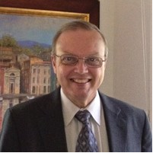Bob Philips

[rj.phillips@ymail.com](mailto:rj.phillips@ymail.com)

Bob is an Agile Coach and Scrum Master with many years guiding companies and teams in the implementation and adoption of Agile principles, practices, and tools - from his former career at IBM to his current senior roles in the finance industry. Bob has been recognized by customers, colleagues, and management for his ability to quickly see challenges that may be impacting teams’ productivity, bringing innovative ideas to help teams solve problems, and building high-performing teams recognized as true partners to stakeholders. Bob is also the Director of Agile Learning at the New Jersey Chapter of Project Management Institute.

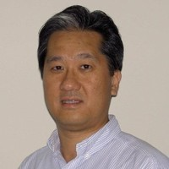

John Tse

[VP-ProfessionalDevelopment@pminj.org](mailto:VP-ProfessionalDevelopment@pminj.org)

John has worked for many years as a Program and Project Manager in a wide variety of information technology projects across industries. He is expert in helping companies successfully plan and execute their IT projects to meet time, cost and scope objectives. John has developed a variety of PMP training courses and content, including at County College of Morris.  John is also the Vice President of Professional Development, and a Disciplined Agile Champion, at the New Jersey Chapter of Project Management Institute.